ROLLING HILLS RIDING CLUB PLAYDAY RULE BOOK

GENERAL RULES
- Riders must always maintain forward motion, not maintaining a forward motion will result in a no time. (only exception is if pattern rules specify)
- In any event, if a barrel or pole is missed, circling back will result in a no time.
- Riders can have assistance entering the arena but there are to be no additional horses (except for judges that are on horses)
- All riders must be ready to enter arena when called. Rider will be called 3 times and if not attempting to enter arena after 3 calls, rider will receive a no time.
- Failure to complete or breaking the pattern of any event will result in a no time. ALL AGE GROUPS, including lead-line.
- Lead-line age group must be lead by another person.
- If a horse re-crosses the start/finish line before pattern is complete, this is considered a broke pattern and will be a no time.
- Dismounting or falling off the horse during the timing of the event results in a no time.
- Contestants will receive a re-ride at the Judge’s discretion in case of interference or equipment failure.
- Judge’s rulings are final. If you have any discrepancies, you must notify a judge immediately, before the end of that event.
- Each playday will consist of 4 events-Barrels, Poles, Flags and a “wildcard” event. Rules for the wild card will be made available prior to the playday.

BARRELS
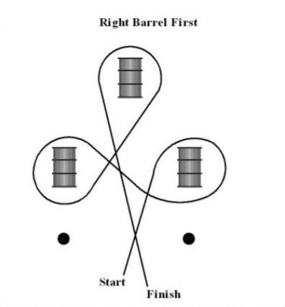
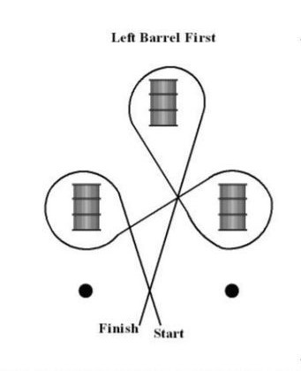
POLES
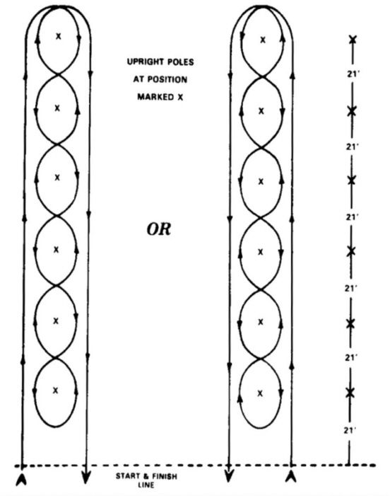

FLAGS
You can start on the right or left side of the arena. If you begin on the right side of the arena you will go on the outside of the barrels to barrel #3 and pick up the flag, then go to barrel #2 and place it in the bucket. If you start on the left side of the arena you will go on the outside of the barrels to barrel #3 and pick up the flag then go to barrel #1 and place it in the bucket.

3

2 1

BARRELS
- Riders may begin the pattern on the right or left barrel.
- There will be a 5 second penalty for each knocked down barrel.
- Touching a barrel is permitted without penalty.
2 BUCKET FLAGS
- Failing to pick up the flag on the first pass and failure to place the flag in the bucket on the first pass results in a no time.
- Dropping the flag results in a no time
- Striking the horse with the flag results in a no time.
- The flag falling out of the bucket before the rider crosses the finish line results in a no time.
- Knocking over any of the barrels or knocking the bucket over results in a no time.
- You cannot circle any barrel; this will result in a no time.
POLES
- There will be a 5 second penalty for each pole knocked over.
- Rider may go to either the left or right side of the poles to begin the pattern.
- Touching a pole is permitted without penalty.

