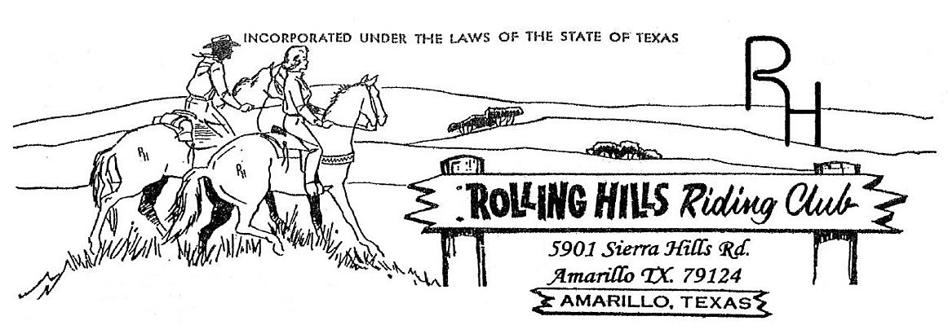

**July 2024**

* July 1st, 2024 -Monthly meeting at 7:30pm

Meeting came to order at 7:34 pm

June minutes read by Michelle, motion to accept by Michael Hsu and second by Amy

June Treasurers report read by Beth, accepted by Amy and second by Djuana

Building fund beginning balance $695.09, paid $55.56 to Waste Wrangler monthly fee.

Deposits of $4,859.55 from Michael R for well repair, ending balance $5,499.08.

General fund beginning balance $4,959.80, paid $86.98 to Xcel for electric. Deposits of $850.00 from saddle sponsor/dues. Ending balance $5,702.82.

**Old business discussed:**

* Well has been repaired. The club will need to reimburse Michael for the repair.

**New business discussed**:

* Parades –July 4th parade. The theme is “Party in the USA”. Brandi will get decorations. We will wear white shirts and decorate the horses with red, white & blue. There will be a float for the non-riders.
* A dance studio would like to rent the club for 3 days – they are a small entity so they will receive a discount with hopes of returning again. The dates are August 29th to August 31st. they will have 4 types of dance lessons (including country), the cost is $15 per person and the final night there will be a dance with a $25 charge per person. If you would like more information, contact Beth.
* The new shirt design was voted on. They will be sold for $17 & $20 (depending on the size). If you would like a shirt you will need to get with an officer with sizes and of course the funds.
* July 20th we will be setting up a booth at Tractor Supply on Gem Lake to sell the gun raffle tickets. We will need some volunteers & kiddos to help sell.
* Any discrepancies or concerns with times or decisions go through the arena director/judges. Any equipment malfunctions is up to the arena director/judges to decide on the outcome.

New Members: Sonia Trillo and family

* Calendar:

July 1st – Meeting @ 7pm

July 20th – game night @ 7

July 20th – raffle ticket sales @ Tractor Supply

July 27th – Playday – books from 5:30 – 6:30 pm start at 7pm NO LATE ENTRIES

Please watch the Facebook page for updates.

**Membership:** If you know someone who would like to become a member, please have them contact an officer. **As always, we welcome any new members to the club!!!**

* **If you have any questions or comments the following is a list of our officers**

- President: Michael Rolen 806-231-0102

- Vice President: Paul Lundegreen 806-202-9683

- Secretary: Michelle Wilcox (Mosa) 806-367-3611

- Treasurer: Beth White 806-789-9318

- Parade Director: Cyndi Lundegreen

- Concession Stand Director: Anita Boyce

- Facilities Director: Matt Marti

- Events Director: Brandi Carver

- Extreme Horse Committee:

-Executive officer—Robbie Hayes, Michael Hsu