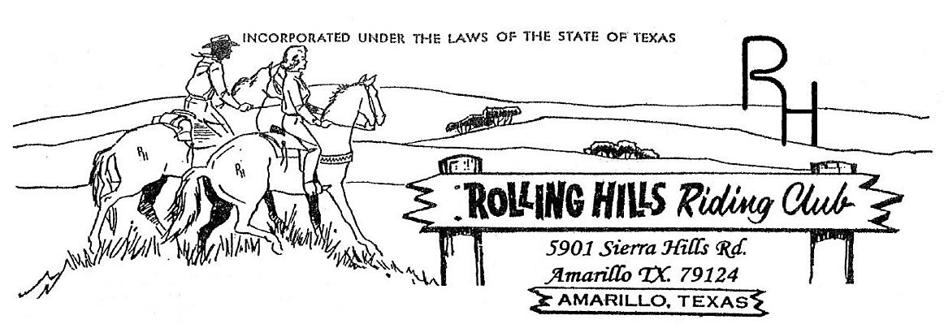

**June 2024**

* June 3, 2024 -Monthly meeting at 7:30pm

Meeting came to order at 7:30 pm

May minutes read by Beth, motion to accept by Paul and second by Amy

May Treasurers report read by Beth, accepted by Amy and second by Djuana

Building fund beginning balance $931.41, paid $180.00 to Brent Daniels for reimbursement of raffle tickets, $56.32 to Waste Wrangler monthly fee.

Deposits of $0.00, ending balance $695.09.

General fund beginning balance $4,560.96, paid $289.85 to Valley Vet for barrel covers, $17.00 to Lonis for the website, $73.05 to Best Buy for office supplies, $71.26 to Xcel for electric. Deposits of $850.00 from saddle sponsor. Ending balance $4,939.80.

**Old business discussed:**

* Still need to get the paint for the poles around the concession area.

**New business discussed**:

* Parades – we are entered in the July 4th parade. The theme is “Party in the USA”. Brandi will get decorations. We will wear white shirts and decorate the horses with red, white & blue. There will be a float for the non-riders.
* There is a problem with the water well, Matt has someone coming to look at it.
* The mention of new members was brought up regarding their membership dues. According to the Bylaws, dues must be submitted with the new member application. All future new member applications will require dues to be paid at the time of submission. If the applicant is not voted in the dues will be returned to the applicant.
* Brandi is still working on the shirt design.
* If there is a need we will be setting up at Tractor Supply, Gebos and/or Ranchers and possibly at Longhorn Futurity to sell the gun raffle tickets. These tickets need to get sold as soon as we can.

New Members: Michele Borrayo

* Calendar:

June 3rd – Meeting @ 7:30 pm

June 22nd – Game night @7pm

June 29th – Playday – book from 5:30 – 6:30 pm start at 7pm NO LATE ENTRIES

July 1st – Meeting @ 7pm

July 27th – Playday – times TBD

Please watch the Facebook page for updates.

**Membership:** If you know someone who would like to become a member, please have them contact an officer. **As always, we welcome any new members to the club!!!**

* **If you have any questions or comments the following is a list of our officers**

- President: Michael Rolen 806-231-0102

- Vice President: Paul Lundegreen 806-202-9683

- Secretary: Michelle Wilcox (Mosa) 806-367-3611

- Treasurer: Beth White 806-789-9318

- Parade Director: Cyndi Lundegreen

- Concession Stand Director: Anita Boyce

- Facilities Director: Matt Marti

- Events Director: Brandi Carver

- Extreme Horse Committee:

-Executive officer—Robbie Hayes, Michael Hsu