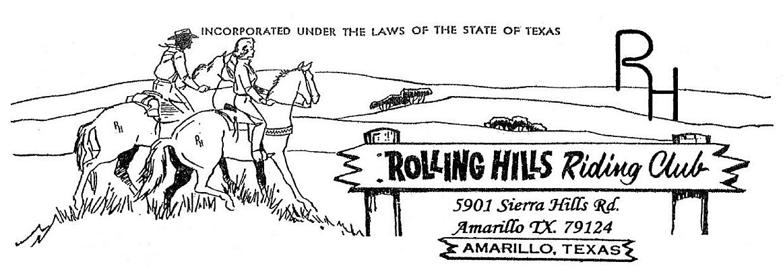

**May 2024**

* May 6th -Monthly meeting at 7:30pm

Meeting came to order at 7:30 pm

April minutes read by Beth, motion to accept by Michael Hsu and second by Amy

April Treasurers report read by Beth, accepted by Amy and second by Djuana

Building fund beginning balance $1,140.51, paid $160.66 to Matt Marti for repai reimbursement, $100.00 transfer to General account for dues, draw of $100 for the concession start-up, $49 to Waste Wranglers for trash and $361.73 to Anita Boyce for reimbursement for concession supplies.

Deposits of $100.35 (from square) for dues, $250.00 for a donation and $212.00 from concession stand at playday, ending balance $931.41.

General fund beginning balance $4,011.20, paid $175.19 to Lonis for website, $42.49 to Cyndi Lundegreen for parade supplies $36.17 for donuts for the clean up day, $100 for the playday start up, $385.94 to Hodges Badge Company for ribbons, and $91.45 to Xcel for electric. Deposits of $100.00 dues, $350.00 from Wilson-Starkeys – sponsor, $931 from playday entries. Ending balance $4,540.96.

**Old business discussed:**

* Still a few things left on the work day list to be completed: paint, practice arena
* Playday had 31 entries. Clarification there is NOT a late fee to enter there are NO late entries at all.

**New business discussed**:

* Banner sponsors – We have two banner sponsors as of May they are Starkey’s Trash Service and Contractors Plumbing of Amarillo. If you have a company that has agreed to a banner please get the money and have them email the logo and wording to Michael Rolen as soon as you can so they can get sent off to the printers.
* We need at least 2 more saddle sponsors so if you know anyone who might be interested please contact them and if they want to sponsor please get with Michael ASAP.
* Cory Waggoner from Randall County Sheriff’s Posse came to discuss the American Association of Sheriff’s Posse. The discussion consisted of the membership – the first year is $25 and thereafter is $65. Michael Rolen our President has volunteered to pay for the first 4 $25 memberships!! – Thank you Michael!!!!

In June there is a playdays final and awards are giving to the top 10 places with the 1st place being a saddle in each age division. Awards are given out in October. The event is a 4 day weekend event starts on Wednesday and goes through Saturday. They have 2 competitive events each day. There are 7 age divisions, Lead line and Novice.

If you want to participate you must be a current member in good standing.

For more information you can look at the Randal County Sheriff’s Posse webpage or the American Association of Sheriff’s Posse website.

Each club member will be assigned duties such as gates, announcer, concession etc. this will not be for the entire time.

* Game night to return!! We will be having them on Saturday nights at 7 pm @ the club house. Bring a game and some finger foods to share. The first one will be May 18th. Hope to see you there and bring a friend or 2 😊
* New T-shirts!! Brandi is going to make 3 designs for voting on so we can all have a vote on the one we like most.
* Parades – we would like to look more uniform so we are encouraging members to get the white button down dress shirts with the logo and RHRC on them. Eventually we would like to see more uniform with not only the dress attire but with the horses. This is a work up to project.
* Raffle tickets were handed out to members. The raffle is for a PSA 308 AR-10 rifle (1st place), 4 burner flat top grill (2nd place) or $100 cash (3rd place) tickets are $10 each. You can get with any of the board to get tickets – numbers are listed at the bottom of the letter. The drawing will be held at the July playday which is on July 27th.
* We reviewed the concession stand prices and feel they align with the club being able to make a profit to go towards the building fund (which is for improvements).
* We added the Palo Duro Playday series to our upcoming events for those interested in attending them

Calendar:

May 6th – Meeting @ 7:30 pm

May 18th – Game night @ 7pm

June 3rd – Meeting @ 7:30 pm

June 22nd – Game night @7pm

June 29th – Playday – book from 5:30 – 6:30 pm start at 7pm NO LATE ENTRIES

July 1st – Meeting @ 7pm

July 27th – Playday

Please watch the Facebook page for updates.

**Membership:** If you know someone who would like to become a member, please have them contact an officer. **As always, we welcome any new members to the club!!!**

* **If you have any questions or comments the following is a list of our officers**

- President: Michael Rolen 806-231-0102

- Vice President: Paul Lundegreen 806-202-9683

- Secretary: Michelle Wilcox (Mosa) 806-367-3611

- Treasurer: Beth White 806-789-9318

- Parade Director: Cyndi Lundegreen

- Concession Stand Director: Anita Boyce

- Facilities Director: Matt Marti

- Events Director: Brandi Carver

- Extreme Horse Committee:

-Executive officer—Robbie Hayes, Michael Hsu