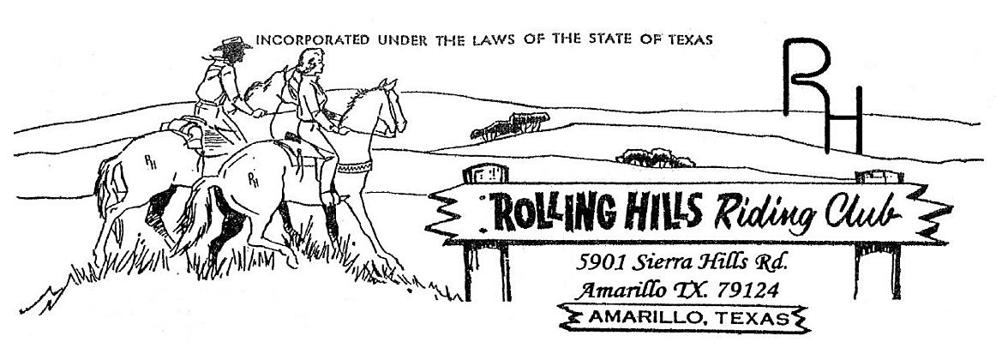

**March 2024**

* March 4th -Monthly meeting at 7:30pm

Meeting came to order at 7:33 pm

February minutes read by Beth, motion to accept by Scott and second by Matt

February Treasurers report read by Beth, accepted by Brandi & second by Amy

**Old business discussed:**

* RHRC Chili Cook-off – Flyers are being hung up throughout. Members need to share the information as much as possible to get the word out. There will be a minimum of 2 gallons.
* Shamrock Parade – March 16th. Line up is at 9 am please be ready. The judges will be walking around taking notes. Posting this on Facebook with more details and to get an idea of how many for a float. And of course – GREEN GREEN GREEN

**New business discussed**:

* Paul received a donation of a 30x60 flag from Kevin Ceawright. We will be looking into getting a pole for it. .
* Scott Hetzel wants to pledge a donation of cash for year end awards. The amount of $50 per age division. This will be for members only. We will start an added money pot for these year end awards. The winners of the awards will be the member with the highest points overall in each age division.
* Matt has been getting saddle sponsors. A motion was made and 2nd to have a high point winner in each age division (with the exception of lead line) to be awarded a saddle. We will need a total of 6 saddles. Please feel free to get with Matt Marti or Michael Rolen regarding the saddle sponsorships. The reserve champions will be awarded buckles and the 3rd place will be awarded a prize TBD.
* Banner sponsors - $300 if they do not have a banner and $250 if they have a banner. These will be placed in the arena for all to see. Let’s get some sponsors.

First playday of the year will be held April 27th. Books will be from 9:30 am to 10:30 am and begin at 11:00 am. Sorry but there will be NO late entries.

Calendar:

March 16th – Shamrock parade

March 23rd – Chili cookoff

April 1st – Meeting at 7:30 pm

April 13th – Cleanup day

April 27th – Playday

Please watch the Facebook page for updates.

**Membership:** If you know someone who would like to become a member, please have them contact an officer. **As always, we welcome any new members to the club!!!**