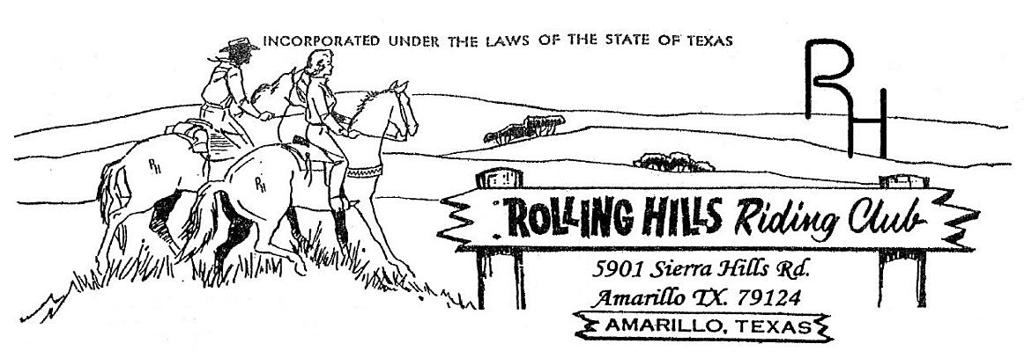

**January 2024**

* January 8th -Monthly meeting at 7:30pm

Meeting came to order at 7:34 pm

December minutes read by Beth White, motion to accept by Amy Hitchcock and second by Brandi Carver

December Treasurers report read by Beth White, accepted by Amy Hitchcock & second by Brandi Carver

Building fund beginning balance $579.41, paid $92.77 to Waste Wranglers, ending balance $486.64.

General fund beginning balance $5,757.71, paid $100.00 to Steve Belote – Steer use, $321.56 Ranchers – bucket contents, $128.80 Tractor Supply – bucket contents, $200.00 to Michael Rolen – reimburse for awards, $481.17 to Greater Armadillo – jackets, $68.23 to Xcel. Ending balance $1,300.30

**Old business discussed:**

* Having family night (board games, cards, etc.) return to the club – games, possible pot luck
* 2024 All Star playday will be at Silver Spurs
* Having special events that will **require** at least 2 volunteers – please get with Michael on events you might be interested in
* Newest member(s) Juan Cabrellos
* CASI sanctioned chili cook-off January 13th – too late to enter this year, possibly next year.

**New business discussed:**

* Special events: Three – 1 @ beginning, 1 @ middle and 1 @ end of 2024
  + Chili cook-off – this will be a NON CASI sanctioned event. This will be our 1st major event of 2024. The date is set for February 24th at the club house.

We will add $100 to the prize money. Winners will receive 50% of intake plus the added $100. Payout will be 1st to 3rd place.

Advertisements will be on Facebook, the radio station(s), News channel and flyers. The more advertising the better turnout – invite friends and family to come and compete. Entry fee will be $40. This will give the club $20 per entry fee and the other $20 goes back to winners accordingly.

* + Barrel race – need to look at the other clubs and organizations in order to set a date. We will also need to do LOTS of advertising when we set the date. This will tentatively be the 2nd special event of 2024 – tabled to the February meeting.
  + Roping – we will need to get the bucking chutes and roping chutes in good working order, as well as the calf return. More information will be decided as we approach a date and time.
  + Extreme horse buckle series – tabled to the February meeting for additional input.
  + Possible hosting a Little Britches Rodeo – will need to get the requirements needed to host as well as dates and events.
* Big (special) event money will be put into the building fund to continue to grow the club.
* We will be having a clean up day that is scheduled tentatively for April 13 @ 8 am

The club will need to look presentable and in order for the upcoming events. Please plan to make the clean up day as this does count towards your participation. Also, the Queen and Princess are encouraged to attend as part of their duties.

* Mention of changing the amounts being charged for the events at the playday to increase by $1.00 per event. This would be $5 for members and $6 for non-members. This will allow for us to not charge for the prize fund (we will actually make more money as a club and the participant actually saves in the end) – allowing all participants to be eligible for the year end prizes.

For example:

Based on 20 participants:

Current fees:

15 members @ $16/event = $240

5 non-members @ $20/event = $100

Total = $340

New proposed fees:

15 members @ $20/event = $320

5 non-members @ $24/event = $120

Total = $440

This is approximately $100 more per playday with a total of $600 for the year.

The average playday for 2023 had approximately 26 participants. September being the most and June being the least.

The change in fees and not having a prize fund will allow for less administration and more funds for the club.

This has been tabled to revisit at the February meeting to gather further input.

**New Rules**: We will be following the rules in the rule book that was created. If there is a challenge with a ruling, you need to speak with the Arena Director or the judges (which includes the Arena Director) if there is still a misunderstanding or concern you can speak with Michael or Paul. In some instances, the arena judges don’t see a broken pattern and the crow’s nest does – they can call down to the judges for a ruling. The rules will follow along with the All-Star rules – forward motion at all times, the only exception is the 9 & under age group – they can stop forward motion but CANNOT back up or circle. We will have handbooks available at each playday for reference and any clarification.

**Additional information**:

* In order to be a member in good standing for the year and eligible to vote at the end of the year, you MUST attend three meetings and three events throughout the year. A member in good standings will have access to the club house and voting rights. Clean-up days and repair days ARE counted as events for those of you who do not attend the playdays.
* If using the arena, please be sure to remove & return any and all equipment (barrels/poles/cones etc.) that you took out to use. Please be sure to shut all gates to the arena. If the gates are left open this could damage them.
* If you have any ideas for the concession stand or events, please do not hesitate to talk to an officer about them, all ideas are welcome to be heard.
* When we have meetings we will try our best NOT to cancel or reschedule – it is important that we come together and communicate to build a better club.
* If you saw and liked the jackets that were purchased for the buckle winners you can get with Beth or Brandi to get one ordered for yourself and for the cost.
* Membership applications can be completed and dues can be paid from now through March. If you are a newer member (within the past few months) talk with Beth about the dues.

Fees are: Single $50 and Family $100 – members must share the same household.

**Dates to add to your calendar**:

February 5th – meeting @ 7:30 pm

February 24th – Chili cook-off @ club – time TBD

March 4th – meeting @ 7:30 pm

April 1st – meeting @ 7:30 pm

April 13th – clean up day @ 8:00 am

* **If you have any questions or comments the following is a list of our officers**

- President: Michael Rolen 806-231-0102

- Vice President: Paul Lundegreen 806-202-9683

- Secretary: Michelle Wilcox (Mosa) 806-367-3611

- Treasurer: Beth White 806-789-9318

- Parade Director: Cyndi Lundegreen

- Concession Stand Director: Anita Boyce

- Facilities Director: Matt Marti

- Events Director: Brandi Carver

- Extreme Horse Committee:

-Executive officer—Robbie Hayes, Michael Hsu

**Membership:** If you know someone who would like to become a member, please have them contact an officer. **As always, we welcome any new members to the club!!!**